EXPERIMENT 9

VIEWS

**Aim:**

* Create student table(studno, name, dept)
* Display Table
* Create view and select
* insert values
* alter view
* Create view check option
* alter view

**Queries:**

* Create student table(studno, name, dept)

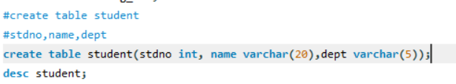

* Display table
* 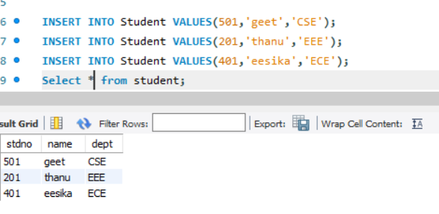
* Create view and select
* 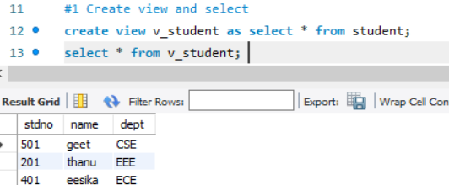
* Insert
* 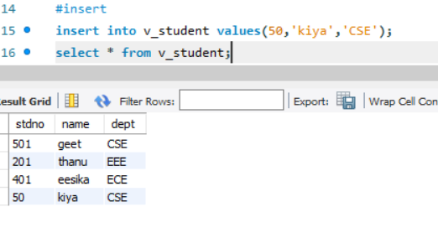
* Alter
* 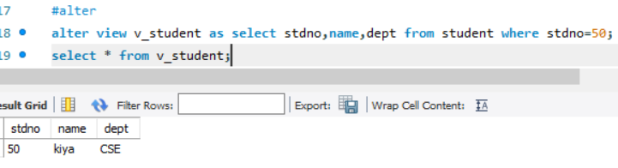
* Create view with check option
* 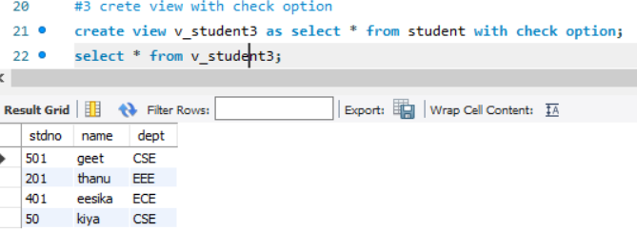
* Alter
* 